Python & MongoDB

Assigment 5

COHDSE182F-022

Dinu Talagune

* Setting up MongoDB in Windows

I have downloaded the zip file from the internet and extracted it in the downloaded folder. Then renamed it as ‘mongodb’ and copy pasted that renamed folder to a folder in E drive(mongoDB). inside that folder I have created another folder name as data, inside that folder also created a folder as db to store relevant data on databases that we are about to make.

Then in the command prompt executed a command which contain the mongod.exe file and the db path (E:\mdb\mongodb\bin\mongod.exe --dbpath E:\mdb\data\db).

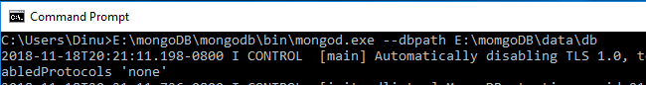

After executing the command on the command prompt.

* Installing pymongo in Python

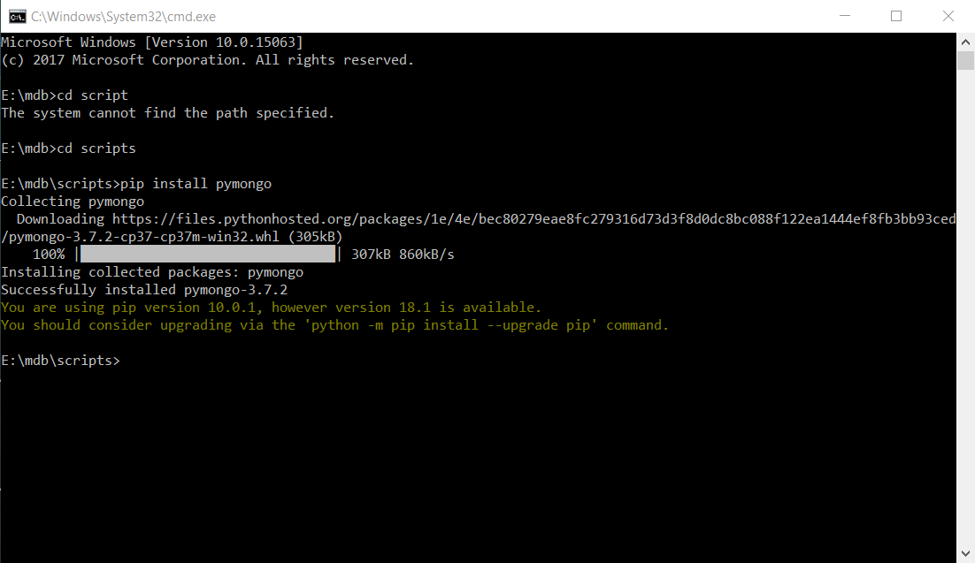

Installing to pymongo in Python, you can use this code : “pip install pymongo”

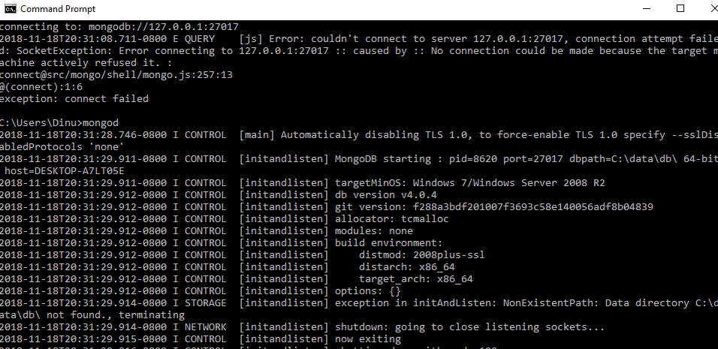

* Run the mongo.exe file

Inside the mongodb file there is a folder name as bin,inside that folder also ther is a exe file name as mongo.exe.

That exe file will work as the mongo shell, we can create, edit, remove any saught of db using that exe file.

After opening mongo.exe file

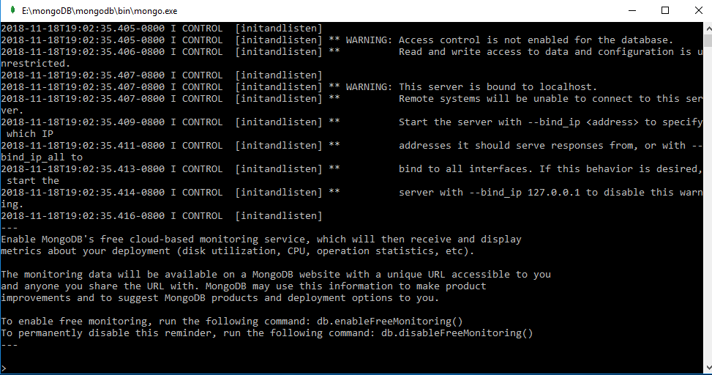

* Create a Data Base using mongo.exe

use DATABASE_NAME

* Create a Collection using mongo.exe

db.createCollection(“COLLECTION_NAME”)

* Insert Values for Collection

Db.”COLLECTION_NAME”.insert ([{column:”value”}])

DB Name :- Assigmentdb

Collection Name:- Users

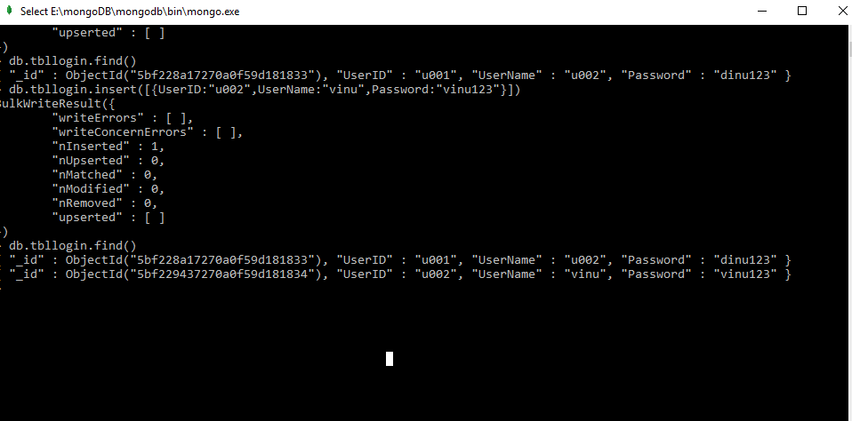

* Entering a data to mongo db by a python code

By establishing a connection between python code and mongodb, we can insert data to any db. I have used a python code

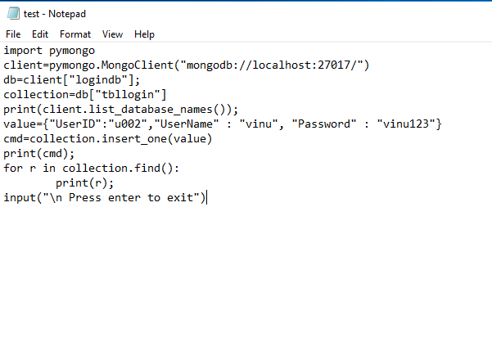

Save code “.py” format

C:\Users\Dinu\Desktop\mongo\Capture1.PNG

* Executing and entering a false data

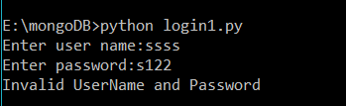

* Executing and entering a true data

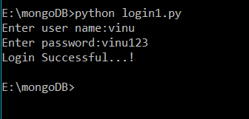

* Finally all the mongo servers are running­­